Solution of (2) is
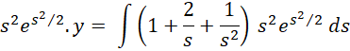
Or,
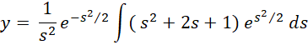
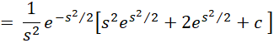
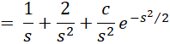
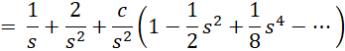
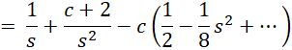

Taking the inverse Laplace transform on both sides, We get
2 = c+2
c = 0
From (3) Y = 1 + 2t which is the real solution.

